Trouble Shooting
Portable Documents Format (PDF)

SOLUTIONS:

Problems Using PDF Fillable Forms Online?
Browsers and 3rd party extensions
Firefox
Chrome

At any time the user can save the file
to their desktop and fill out the form

How do I save PDF forms to my computer?

1. Right click your mouse on the PDF form’s link; Select ‘Save Target as’; Locate where you wish to save the file on your hard drive; and Click ‘Save’.

2. Opened, whether saving a filled-in or unfilled form, the procedure is the same. From the Adobe Reader® top menu, Select ‘File’; Select ‘Save As’; Locate where you wish to save the file on your hard drive; and Click ‘Save’.

When I download a PDF form, I get a message claiming that the PDF file is damaged
(or corrupted). Is your file damaged?

All of our PDF files are verified prior to posting on the web site. Most likely your download was not successful. Exit your browser and try to download the file again.

A recent trend in browser development is to disable
third party extensions. I.E. Adobe Acrobat. If you open
a document and see this text ...

“Please wait…. If this message is not eventually replaced by the proper contents of the document your PDF viewer may not be able to display this type of document…”

You will have to enable your browser to view the PDF document.

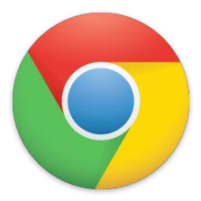
Firefox Chrome

Firefox PC
Options/Applications/Portable Documents Format (PDF) and select Use
Adobe Acrobat (in Firefox)

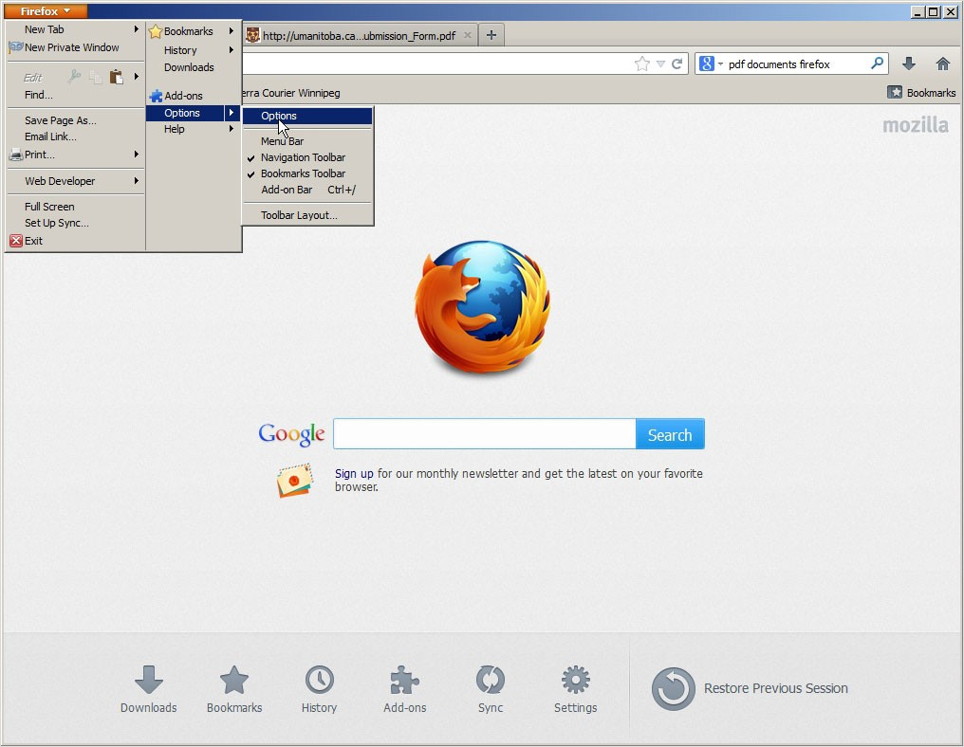

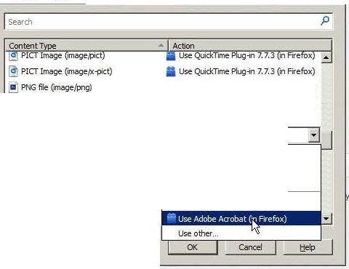
Firefox PC

+ fit Go to a Webs1te
x Jllhttp:lfunanitoba.ca...ubmission_Form.pdf +

A C IIf3• pdf documents firefox

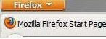
SJ Research G University of Manitob... r/.t Sierra Courier Winnipeg
I'J Bookmarks

'"'i...

Opbons -
General Tabs Content Applications Privacy Security Sync Advanced

!!) PNu file Omage{xi'OQ)
Podcast
mPortable Document =ormat (PDF)
PostScript File
Quicklime Image
(S Quicklime Movie
I!) SWF file
[J Text Document

uownloads ookmarl<s !Story
a Use Quicklime Plug•n 7.7.3 n Firefox) IIuse l.;!U1ck11me 1-'lug-sn / ,J,:j (In 1refox) CD Preview in Firefox
I.a Use Adobe Acrobat (In Firefox)
rJJPreview in Firefox IJl Always ask li!:ilsave File

{buse Adobe Acrobat (default)

('J 0
Add-ons ync ettlngs

Search

our favorite

@) Restore Previous Session

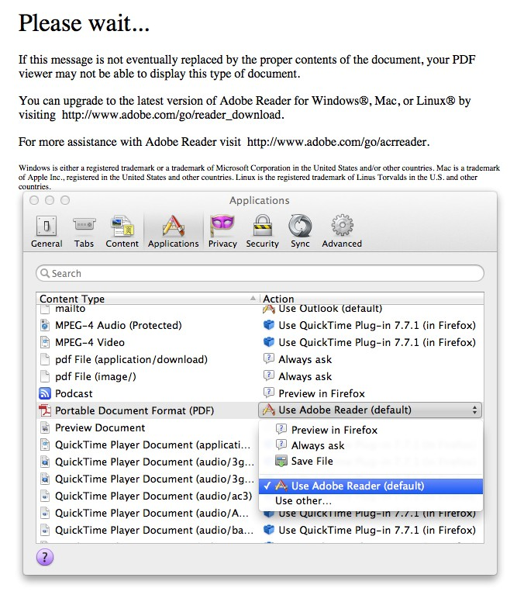
Firefox Mac

Under preferences go to
Applications

Look for Portable Document
Format (PDF)

Click on Use Adobe Reader
(default)

You’re done

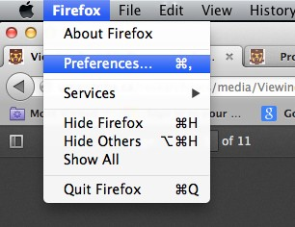

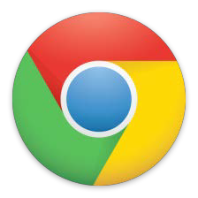
Chrome
The latest version of Chrome i.e. Chrome 25 has made some changes to the
extensions installed by third party programs.

“Extensions installed by third party programs using external extension deployment options will be disabled by default. When a third party program installs an extension, the Chrome menu will be badged, and users can click through the Chrome menu to see a dialog containing an option to enable the extension or to remove it from their computer.

In addition, all extensions previously installed using external deployment options will be automatically disabled. Chrome will show a one-time prompt to allow the re-enabling of any of the extensions.”

Chrome
Click “Settings” on the Chrome menu

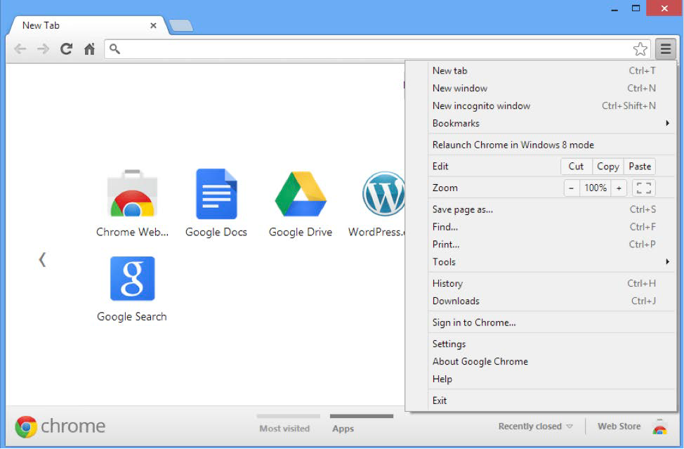

Chrome
Select “Extensions”. You will see “Adobe Acrobat – Create PDF” listed there.
Check the “Enable” box alongside it. This will enable Adobe Acrobat PDF
Creation extension on your Chrome browser.

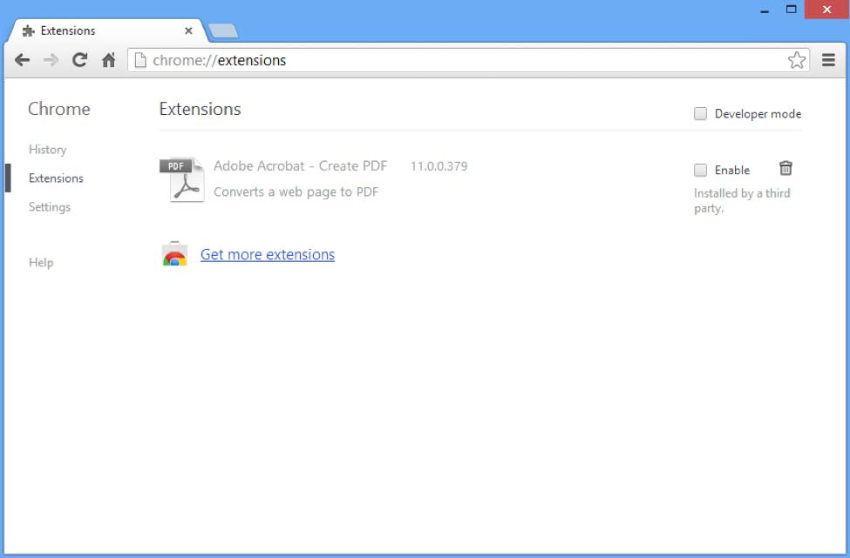

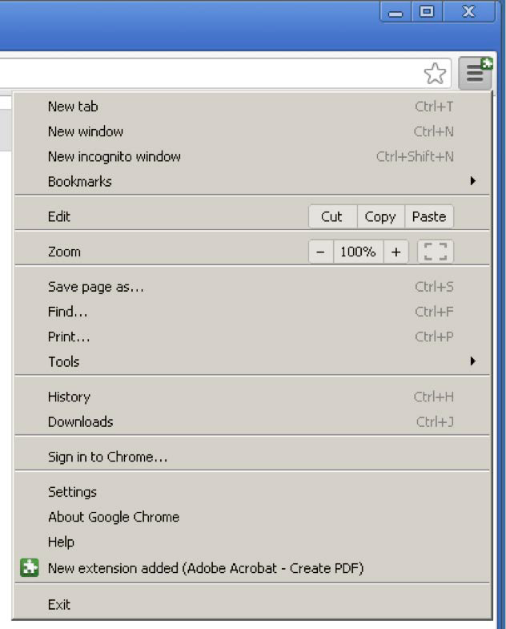
Chrome
If you are doing a fresh installation of
Acrobat, you will see a green badge
on Chrome browser menu (after
Acrobat installation is completed).
You can then click through the
Chrome menu to see a dialog
containing an option to enable the
extension. Select “Enable extension”
to enable Adobe Acrobat PDF
Creation extension on your Chrome
browser.

Click on the PDF icon in the menu bar and select open in PDF

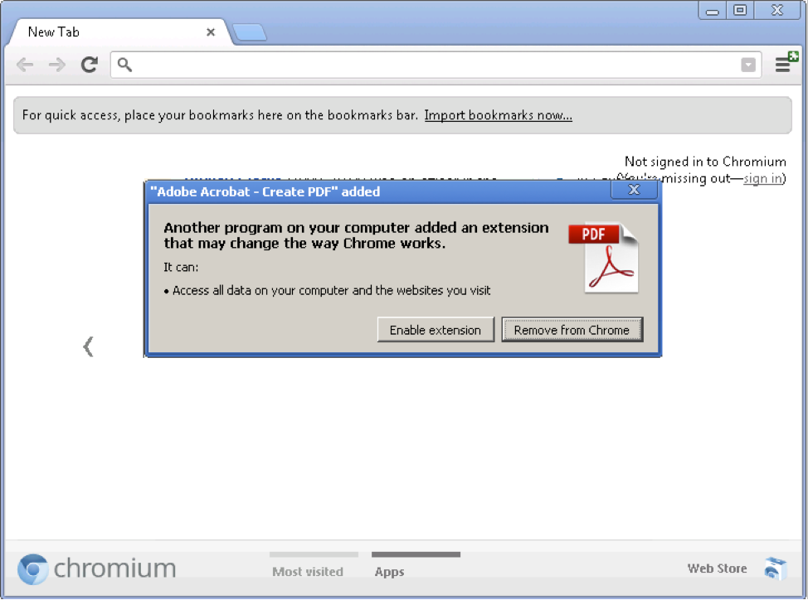

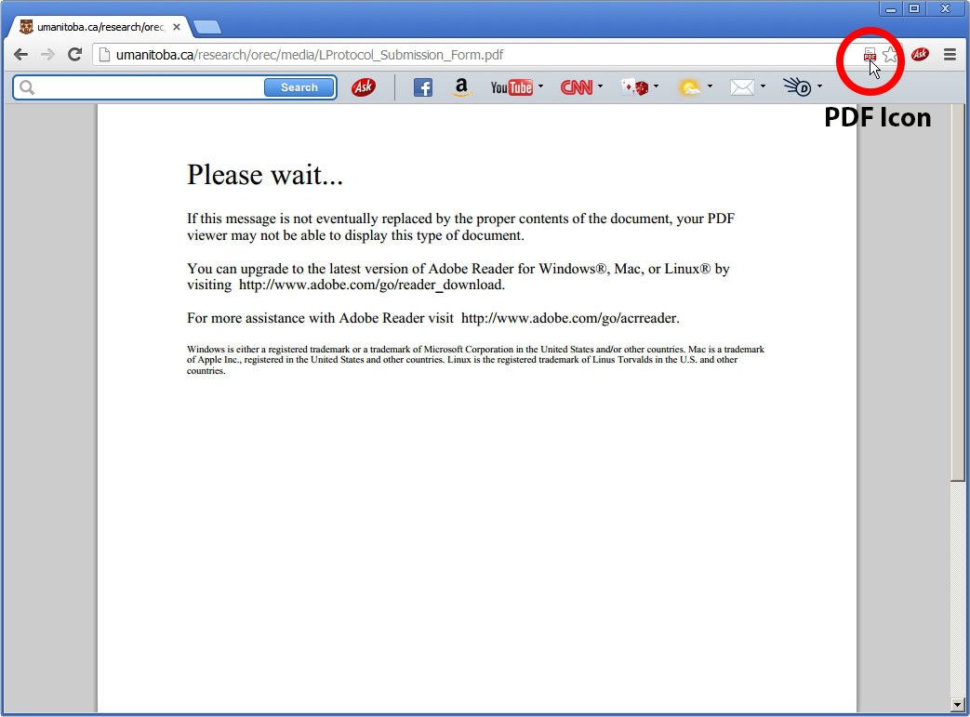
Or you can click on the PDF icon in the menu bar and select open in PDF

Read more here:
http://blogs.adobe.com/acrobat/tip-google-chrome-the-
adobe-acrobat-create-pdf-extension/

